Analysis of billionaires across the World

Abstract

This project developed a custom R function to efficiently load and preprocess the billionaire dataset by utilizing column type metadata from an Excel file, ensuring accurate data interpretation. Through exploratory visualizations, key global trends in billionaire wealth distribution and origins were identified across different decades. The analysis employed diverse plots to test claims about self-made versus inherited wealth patterns, providing data-driven insights into regional and sectoral variations.

# Introduction

Forbes has commissioned this analysis to evaluate two central claims about global billionaire wealth trends using data spanning three decades (1990s–2010s). The first claim posits that the United States has seen a rise in self-made billionaires with minimal generational wealth ties, while other developed and emerging markets remain dominated by inherited wealth. The second claim suggests that software has eclipsed consumer services as the primary sector for new self-made billionaires, with this shift linked to national GDP levels. By interrogating these assertions, this report aims to uncover whether the data supports these patterns or reveals more nuanced realities about wealth creation across regions and industries. The findings will inform Forbes’ ongoing efforts to refine its billionaire database and provide evidence-based insights into global economic mobility.

# Data visualisation

## Industry with more billionaires

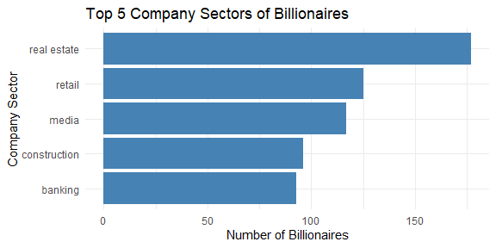 The bar chart displays the top 5 company sectors where billionaires are involved. Real estate leads significantly, having the highest number of billionaires, followed by retail and media. Construction and banking also feature prominently but with fewer billionaires. This suggests that real estate is the most lucrative sector among billionaires in the data set.

## Number of billionaires by region

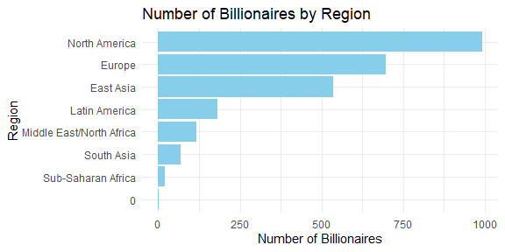 This bar plot displays the number of billionaires across different global regions. North America leads by a wide margin, hosting nearly 1,000 billionaires, highlighting its strong economic concentration. Europe and East Asia follow, each with several hundred billionaires, reflecting their established and emerging markets. Other regions like Latin America, Middle East/North Africa, and South Asia show significantly fewer billionaires, while Sub-Saharan Africa has the lowest count, suggesting disparities in wealth accumulation and economic opportunity across regions.

# Analysis

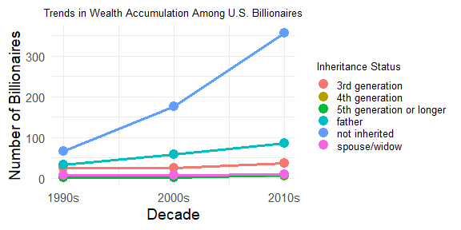

Caption Here

The graph shows a steady dominance of “not inherited” wealth among US billionaires across the decades. Starting in the 1990s, billionaires without generational wealth were already the largest group, but this number increased sharply after 2000, indicating a rise in self-made billionaires. The second most common inheritance path is wealth from fathers, while other categories like “3rd generation”, “spouse/widow”, and “5th generation or longer” remain consistently low and relatively unchanged over time.The data supports the first part of the claim: “In the US, you saw an increasing number of new billionaires emerge that had little to no familial ties to generational wealth.” Indeed, the number of self-made billionaires in the US — those who did not inherit their wealth — has grown significantly, especially after the early 2000s. This suggests an increasing trend of entrepreneurial success and new wealth creation.

## Other countries

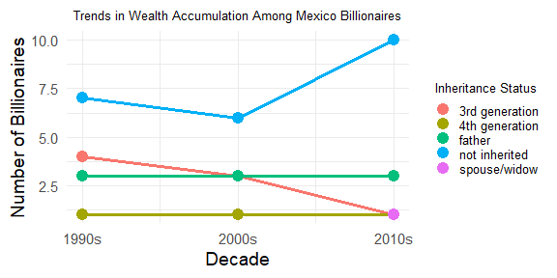

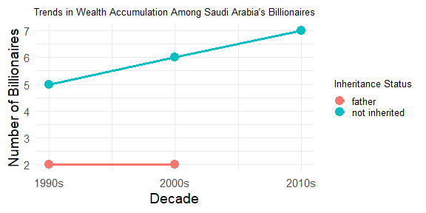

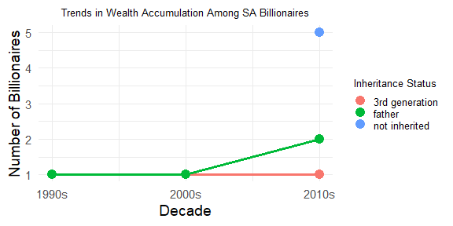 The plots results above challenge the latter part of the claim that emerging and developed markets tend to house mostly inherited wealth. In Mexico, the pattern closely mirrors the U.S., with a dominant presence of self-made billionaires and shifting inheritance trends over time, showing strong entrepreneurial emergence. In contrast, countries like Saudi Arabia and South Africa show different dynamics, mainly due to a smaller billionaire population, making it harder to generalize trends. Despite lower representation, not all wealth in these nations stems from inheritance, suggesting nuanced paths to wealth. Therefore, the claim oversimplifies the diversity of wealth accumulation across global markets.

# Conclusion

The analysis substantiates the claim that the U.S. has experienced a significant increase in self-made billionaires, with data showing a clear decline in reliance on inherited wealth over time. However, it challenges the broader generalization about other markets, as countries like Mexico demonstrate similar entrepreneurial trends, while others (e.g., Saudi Arabia) exhibit context-specific wealth accumulation patterns. Sector-wise, real estate—not software—remains the dominant industry for billionaire wealth, though technology-driven economies show growing influence in newer wealth creation. These findings underscore the need for Forbes to adopt a more nuanced framework for assessing global wealth dynamics, one that accounts for regional variations and evolving sectoral impacts. The data reaffirms the rise of self-made wealth in the U.S. but cautions against oversimplifying the diverse pathways to billionaire status worldwide